August 2023

Dear Parents/Guardians:
As a parent/guardian of a student attending North Brandywine Middle School, a school that is receiving Federal Title I dollars, you have the right to know if your child is assigned to or taught for four (4) or more consecutive weeks by a teacher who does not hold the appropriate state certification.

Presently, your child is being taught by a teacher who is not appropriately state certified. This includes teachers holding a State Emergency Certification, taking the required credits toward his/her permanent certificate to make him or her “Appropriately State Certified” as required by the Every Student Succeeds Act.

A professional development plan is currently being implemented by his/her teacher. In the meantime, we will be closely monitoring the delivery of the educational services to your child to ensure a quality education from the teacher assigned to his/her class.

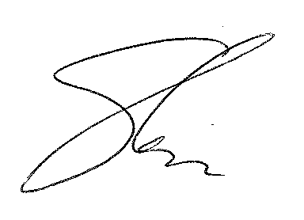
Sincerely,

Dr. Eugenia Roberts,
PRINCIPAL

